Southern Blight - This fungal disease is most common in warmer climates. Mulch with compost after planting peppers, and rotate plants to avoid planting peppers in the same plot 2 years in a row.
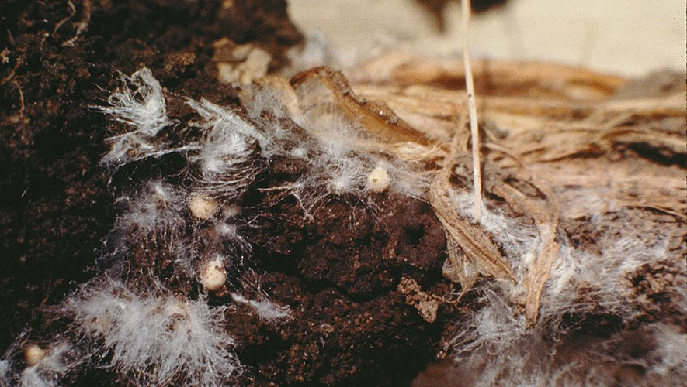
PHOTOGRAPH BY CIMMYT/FLICKR
Viruses
Mosaic is the most serious viral disease for peppers. Leaves become narrow and thickened, and they appear stringy. Pull and dispose of severely affected plants.

Damping-Off
Seedlings that suddenly fall over and rot are most likely affected by
damping-off. Prevent this problem by keeping the soil in which seedlings grow slightly dry and by not over-watering

10 Pests and Diseases Most Likely To Afflict Peppers

Blister Beetles - The striped beetle is both friend and foe; adults feed on pepper plants and other vegetables, but their larvae eat grasshopper eggs. Knock adults from plants into soapy water, but wear gloves because contact with crushed beetles blisters skin.
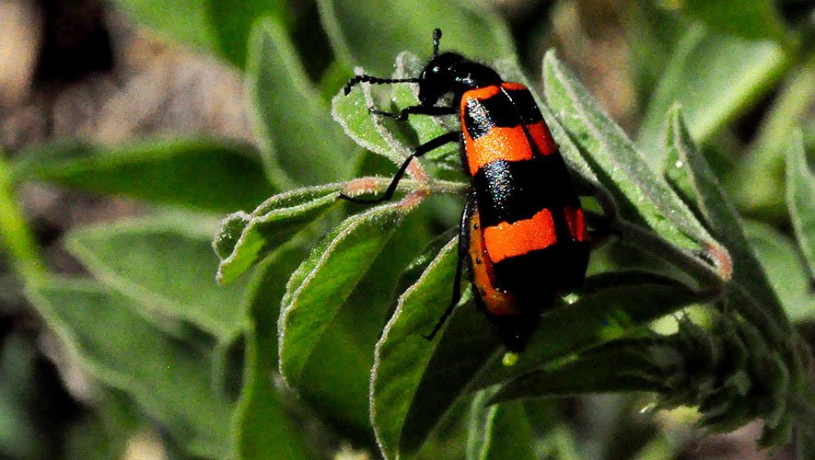
PHOTOGRAPH BY SARA MURRAY/FLICKR

Cutworms - The nocturnal cutworm caterpillar attacks plants by curling around seedling stems and eating through them. Use cutworm collars and apply beneficial nematodes to the soil.
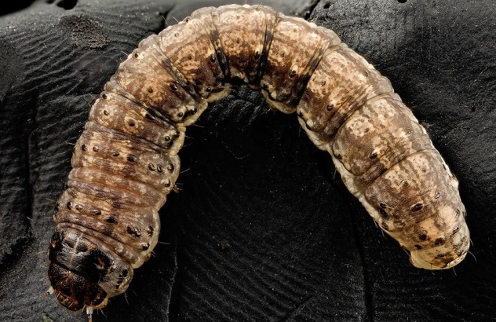
PHOTOGRAPH COURTESY USGS BEE INVENTORY AND MONITORING LAB
Tomato Hornworms - The bright green larvae of this moth species chew large holes in leaves and may completely strip young plants. Handpick caterpillars and then drop them into soapy water.
Damping-Off
Seedlings that suddenly fall over and rot are most likely affected by
damping-off. Prevent this problem by keeping the soil in which seedlings grow slightly dry and by not over-watering

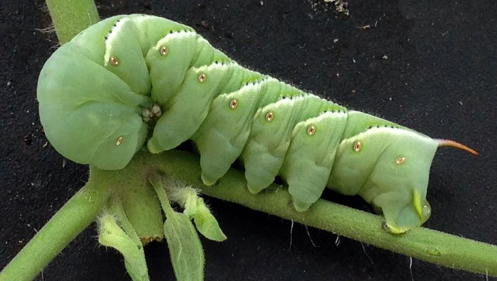
PHOTOGRAPH BY SCOT NELSON/FLICKR

Pepper Weevils - These ¼-inch-long, dark gray insects lay eggs in pepper buds or fruits. The larvae leave dark cavities in the spongy inner tissues of pepper fruits. Invite natural predators such as birds and wasps to dine on these pests.
PHOTOGRAPH BY ALTON SPARKS/WIKIMEDIA

Root-Knot Nematodes - Microscopic soil-dwelling worms cause plants to wilt and lack vigor. To eradicate nematodes, grow a cover crop of marigolds or rye in infested areas and turn.
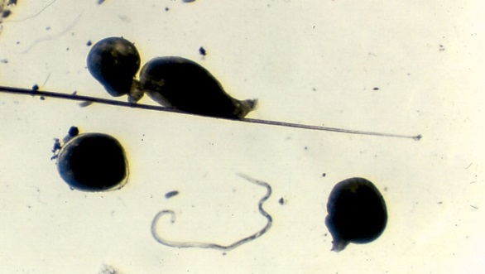
PHOTOGRAPH BY SCOT NELSON/FLICKR

Blossom-end Rot - A lack of calcium leads to the development of this disorder, which creates dark brown or black spots on the bottoms of immature fruits. Keep plants evenly watered to ensure a steady flow of calcium to the plant, especially while fruit is forming.
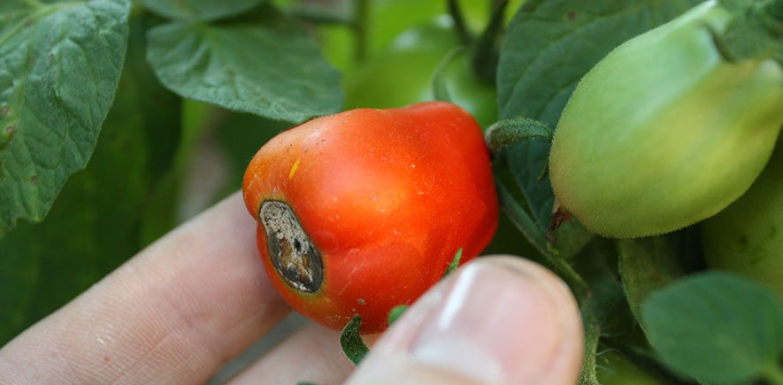
PHOTOGRAPH BY A13EAN/WIKIMEDIA
.
Bacterial Spot - This bacterial disease causes purplish gray spots on upper sides of leaves and raised ones on the backs of leaves. Pull up and dispose of infected plants.
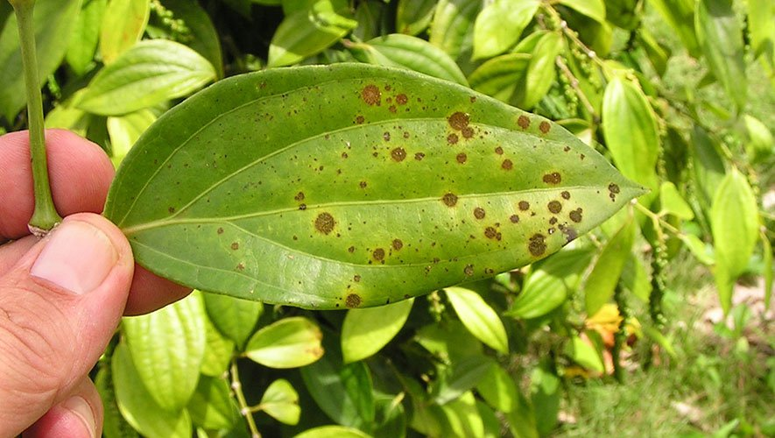
PHOTOGRAPH BY SCOT NELSON/FLICKR

